Name__________________________________
WEATHER- THE WATER CYCLE
Water on Earth is constantly moving. It is recycled over and over again. This recycling process is called the water cycle.

1. Water evaporates into the air
The sun heats up water on land, in rivers, lakes and seas and turns it into water vapour. The water vapour rises into the air.

2. Water vapour condenses into clouds
Water vapour in the air cools down and changes back into tiny drops of liquid water, forming clouds.

3. Water falls as precipitation
The clouds get heavy and water falls back to the ground in the form of rain or snow.

4. Water returns to the sea
Rain water runs over the land and collects in lakes or rivers, which take it back to the sea. The cycle starts all over again.

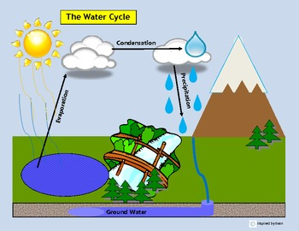
Here is a diagram of the water cycle. Although the water on earth is constantly changing, there is always the same amount of water.
Can you answer the following questions? Circle the right answer.
- When water vapour cools down, it forms:
LAKES MOUNTAINS CLOUDS

- When clouds get heavy, water falls back to the ground as:
CLOUDS SUN RAIN SNOW SLEET
(clue: there are 3 correct answers for question 2 )
- When water collects in lakes and rivers, it finds its way back to the:
MOUNTAINS SEA SNOW

- This process is called the:
WATER FALL WATER TAP WATER CYCLE
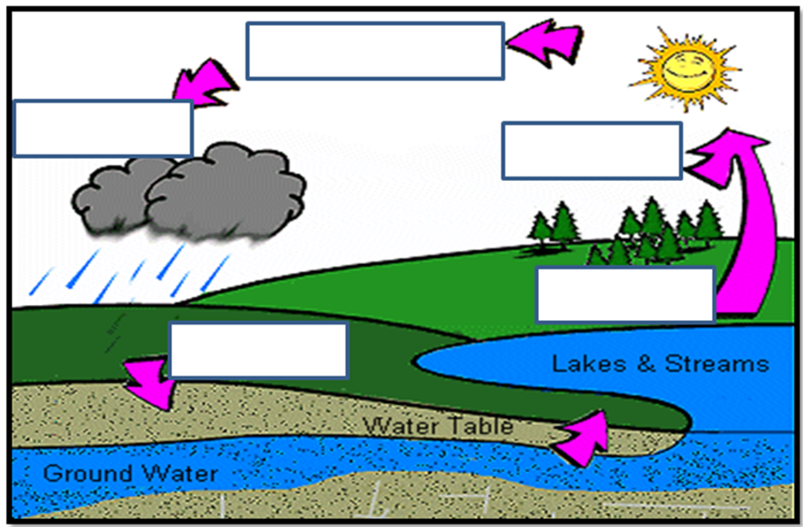
Now see if you can put the right words in the boxes. The words are below to help you.

PRECIPITATION GROUND WATER
CONDENSATION EVAPORATION

