PERSONAL AND SOCIAL DEVELOPMENT
Look at the road signs and try and match them.
There is one road sign which you will not see in this country. Which one is it?
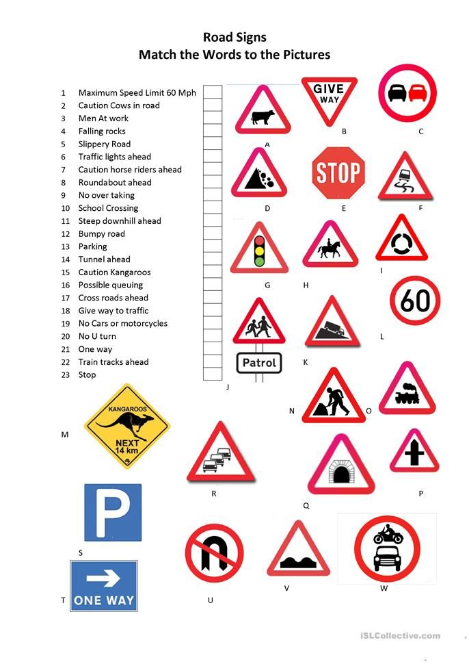
Answers

1 | L
2 | A
3 | N
4 | D
5 | F
6 | G
7 | H
8 | I
9 | C
10 | J
11 | K
12 | V
13 | S
14 | Q
15 | M
16 | R
17 | P
18 | B
19 | W
20 | U
21 | T
22 | O
23 | E
Did you spot the unusual road sign?
It was M.
I don’t think I’ve ever seen a kangeroo on the roads in England.
Have you?

