GARDENING 2 Name _________________________
Which of these are good or bad for the garden. Circle good or bad
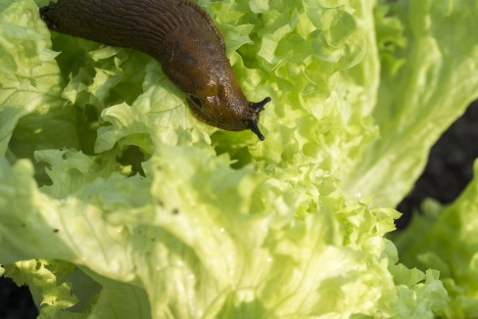 SLUGS GOOD OR BAD
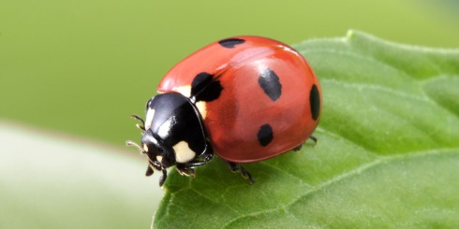 LADYBIRDS - GOOD OR BAD
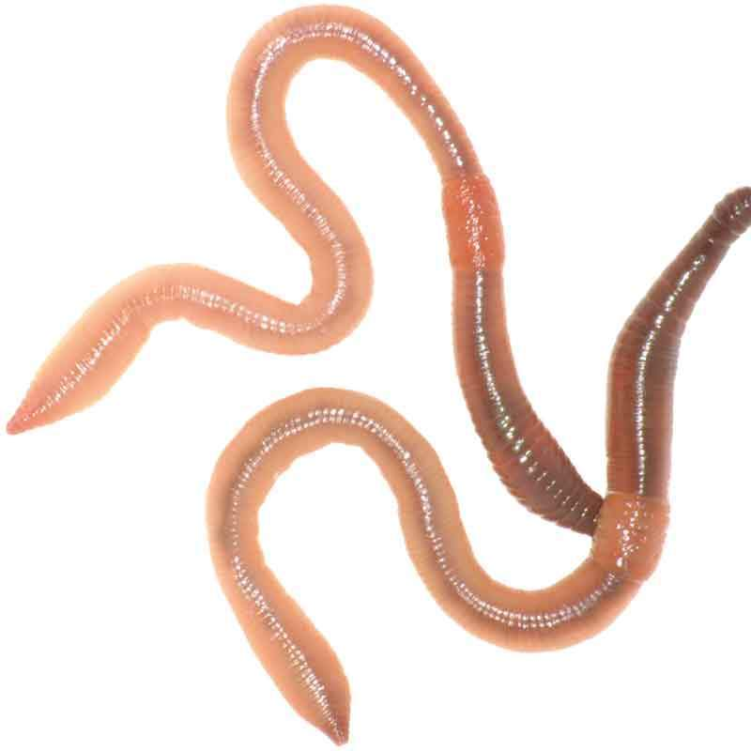 WORMS - GOOD OR BAD
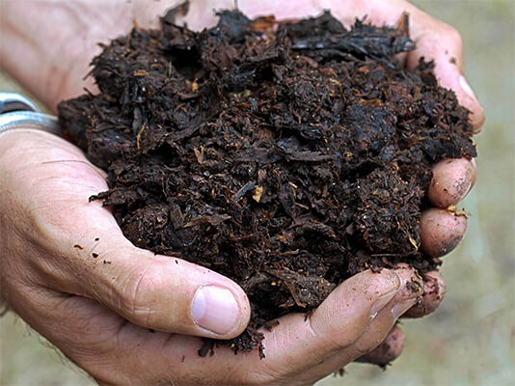 MANURE - GOOD OR BAD
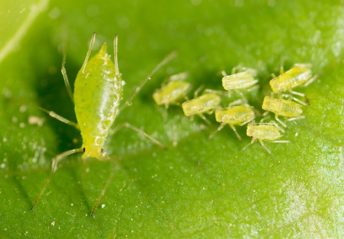 APHIDS - GOOD OR BAD
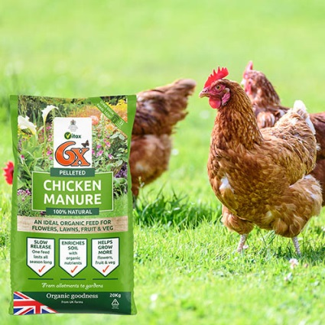 CHICKEN PELLETS - GOOD OR BAD
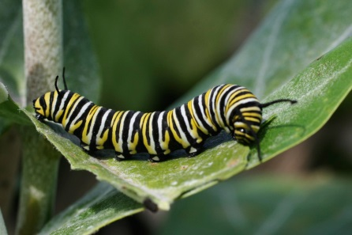 CATERPILLER -- GOOD OR BAD
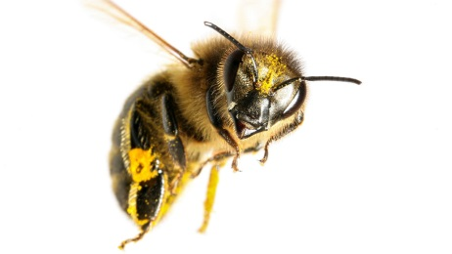 BEES - GOOD OR BAD
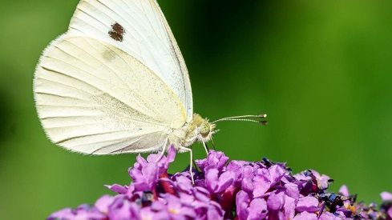 CABBAGE WHITE BUTTERFLY - GOOD OR BAD
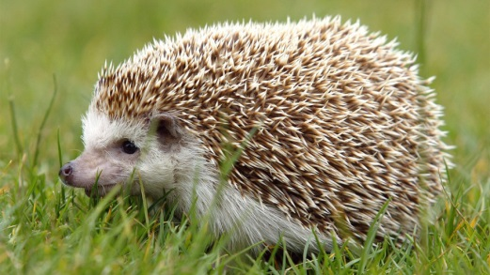 HEDGEHOGS - GOOD OR BAD

