Name_______________________________
STAYING HEALTHY
It’s important to make sure we get the right amount of different foods on our plate when we eat a meal. It’s what we call balancing our diet. It keeps our bodies at a healthy weight and can protect us from illness.
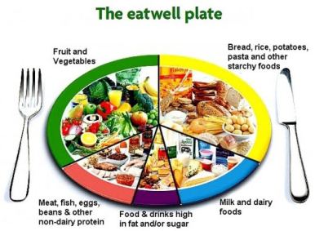
This is called the Eatwell Plate:

Aim to eat at least 5 portions of a variety of fruit and veg each day. Choose from fresh, frozen, tinned, dried or juiced.
Milk, cheese, yoghurt and fromage frais are good sources of protein and some vitamins, and they're also an important source of calcium, which helps keep our bones strong.
Choose lean cuts of meat and mince, and eat less red and processed meat like bacon, ham and sausages.
Aim for at least 2 portions of fish every week, 1 of which should be oily, such as salmon or mackerel.
Foods that are high in fat and sugar should be eaten sparingly. These foods include chocolate, cakes, biscuits, sugary soft drinks, butter, and ice cream.
They're not needed in our diet, so should be eaten less often and in smaller amounts.

See if you can draw a meal that has the right balance of each type of food on the diagram below.

