THE FILM MAKING GROUP
MONDAY GROUP
CAN YOU NAME THESE FAMOUS FILMS FROM THE PICTURE CLUES

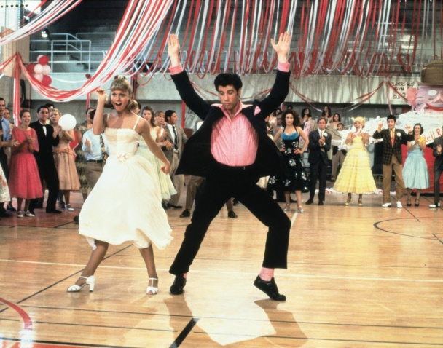

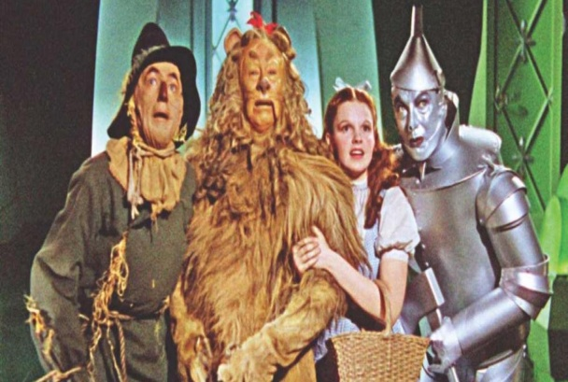

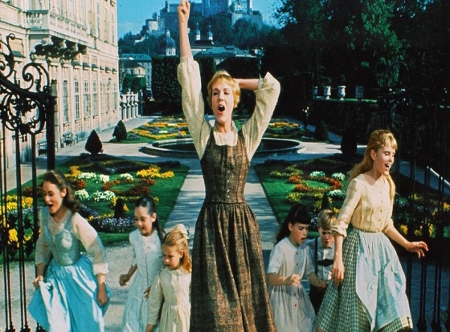

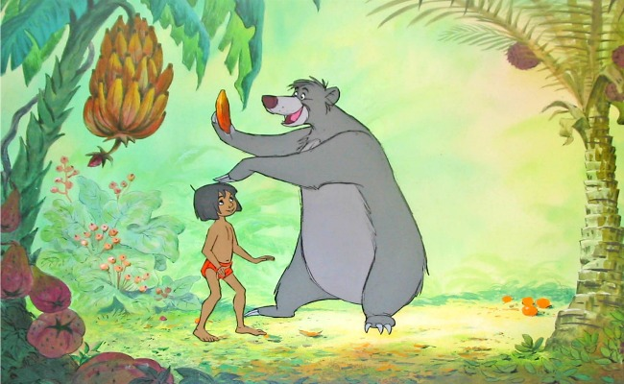

THESE FILM NAMES ARE HERE TO HELP YOU.

GREASE, SOUND OF MUSIC, JAMES BOND, JAWS, JUNGLE BOOK, WIZARD OF OZ, MAMA MIA.

