PRACTICAL WORKSHOP
Since September the group have made a number of items. Here are pictures of some. To make it harder answers are not given – it’s all up to you !
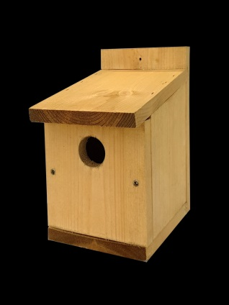 B___ N___ B__
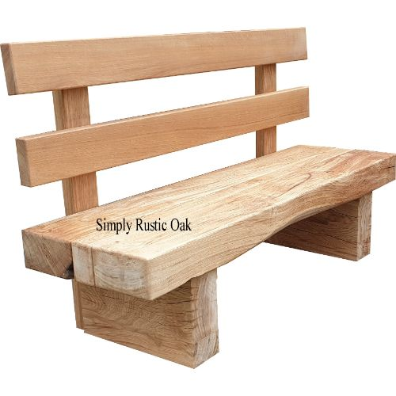 G__________ B_______
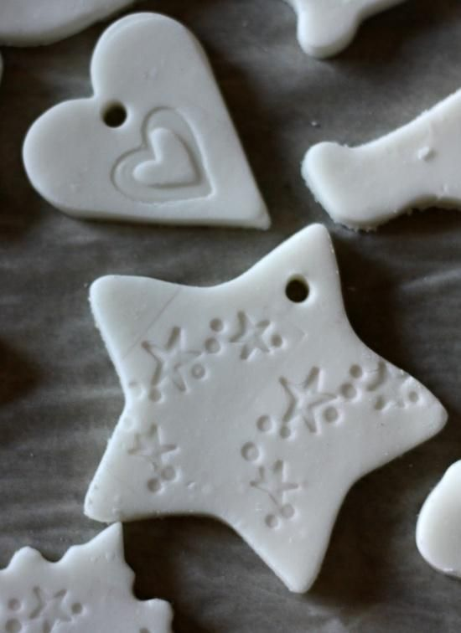 c____________ d_________

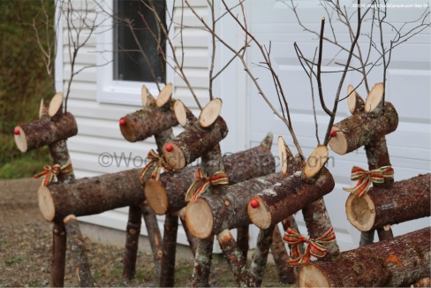 r _________________

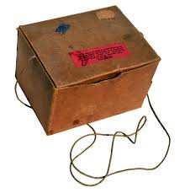 G __ M___ B____

