ASDAN WIDER WORLD

Using your own choice of colours, complete this map of South America. Make sure you use a different colour for each country.

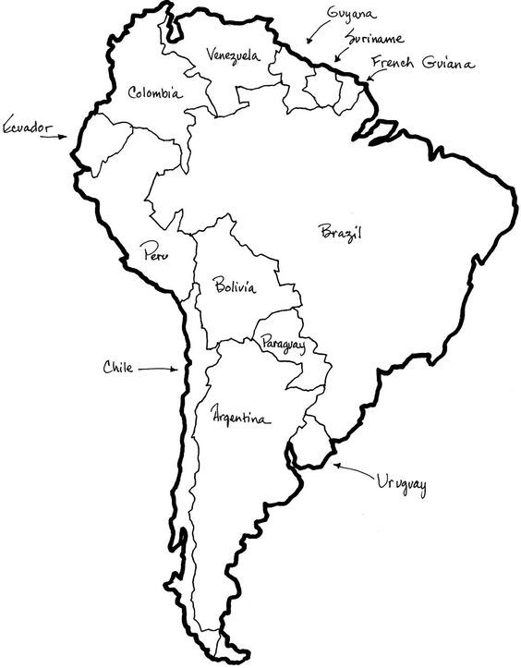

Map Of Central And South America Coloring Sheet

