WHERE I LIVE – Here are some well-known shop logos/signs.
Next to the sign write in what you might buy there. To help you answers are given at the bottom of page 2

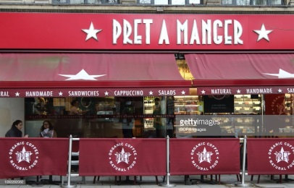 _________________________________

_________________________________
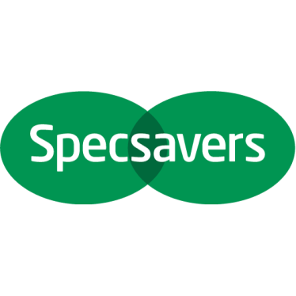 _________________________________
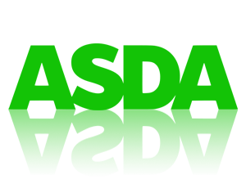 _________________________________
_________________________________
_____________________________________
_____________________________________
_____________________________________
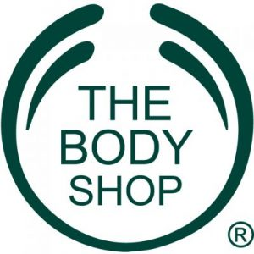 _____________________________________
ANSWERS
COFFEE - A BICYCLE -- SPECTACLES – GROCERIES - A TELEVISON
FOOTBALL SHIRT – LUNCH - PRESCRIPTION MEDICINES – BODY WASH

