Personal and Social Development

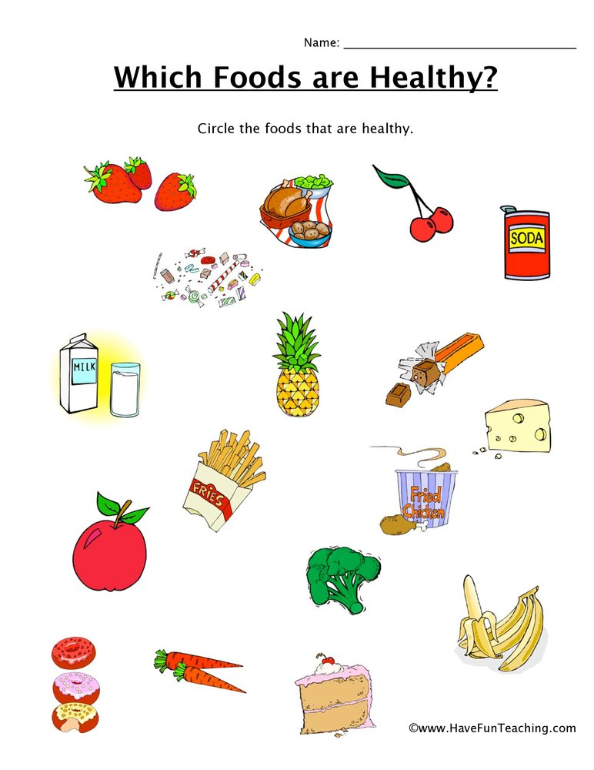

Healthy Food Answers

These are the healthy foods

Strawberries
Cherries
Pineapple
Apple
Broccoli
Carrots
Bananas
Chicken dinner
Milk

