THE WIDER WORLD
WEDNESDAY GROUP
EVERY COUNTRY HAS THEIR OWN WAY OF DRESSING, ON SPECIAL OCCASIONS THEY WEAR THEIR NATIONAL DRESS. CAN YOU NAME THE COUNTRIES THESE PEOPLE ARE FROM
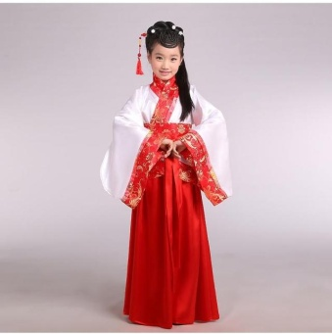

--------------------------------

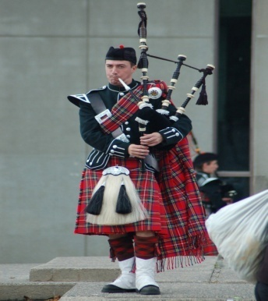

---------------------------------

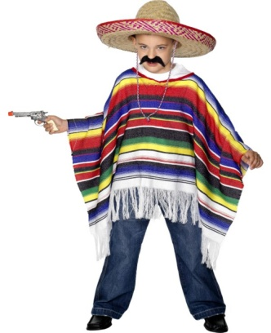

---------------------------------

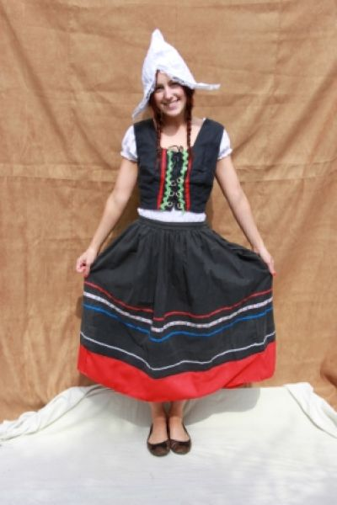
---------------------------------

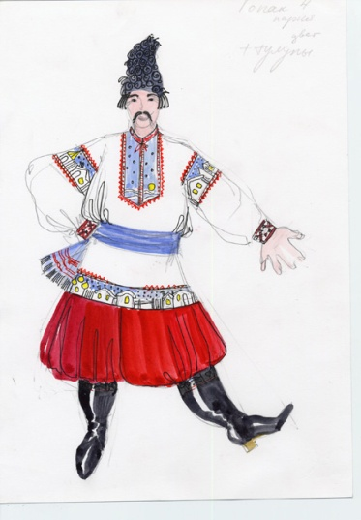

--------------------------------

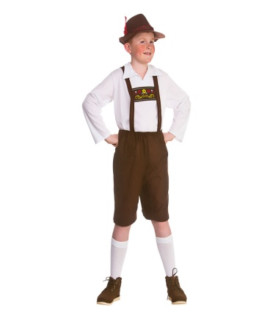

--------------------------------

THESE COUNTRIES BEL0W ARE TO HELP YOU

HOLLAND GERMANY MEXICO RUSSIA SCOTLAND CHINA

