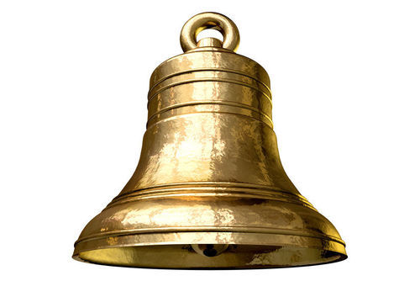 | 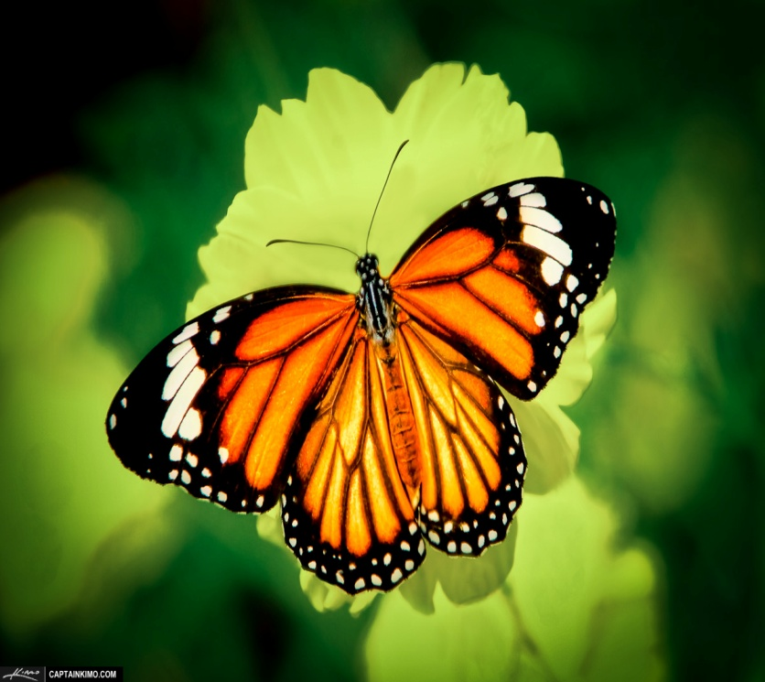
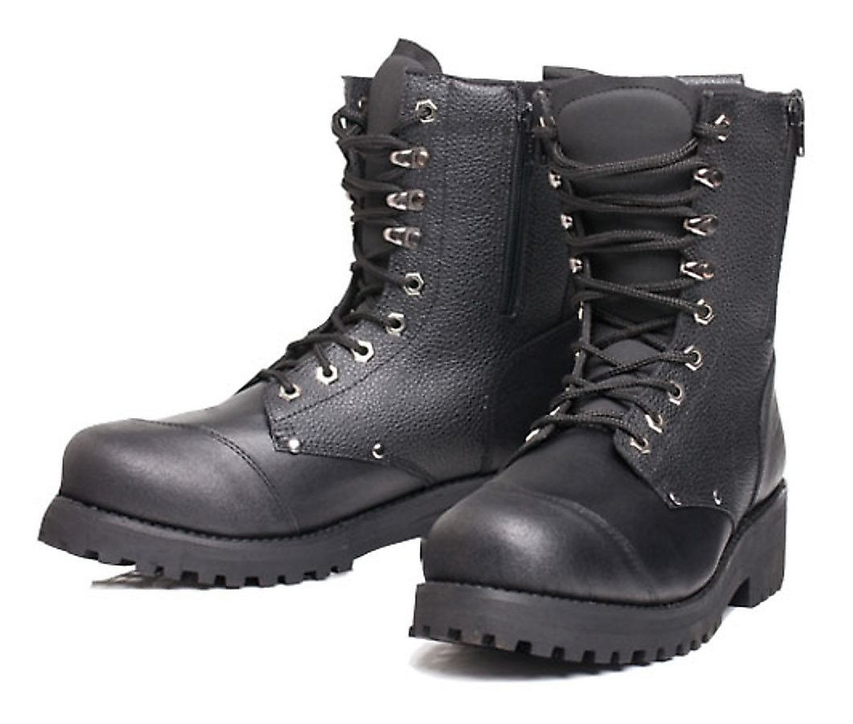 |  | 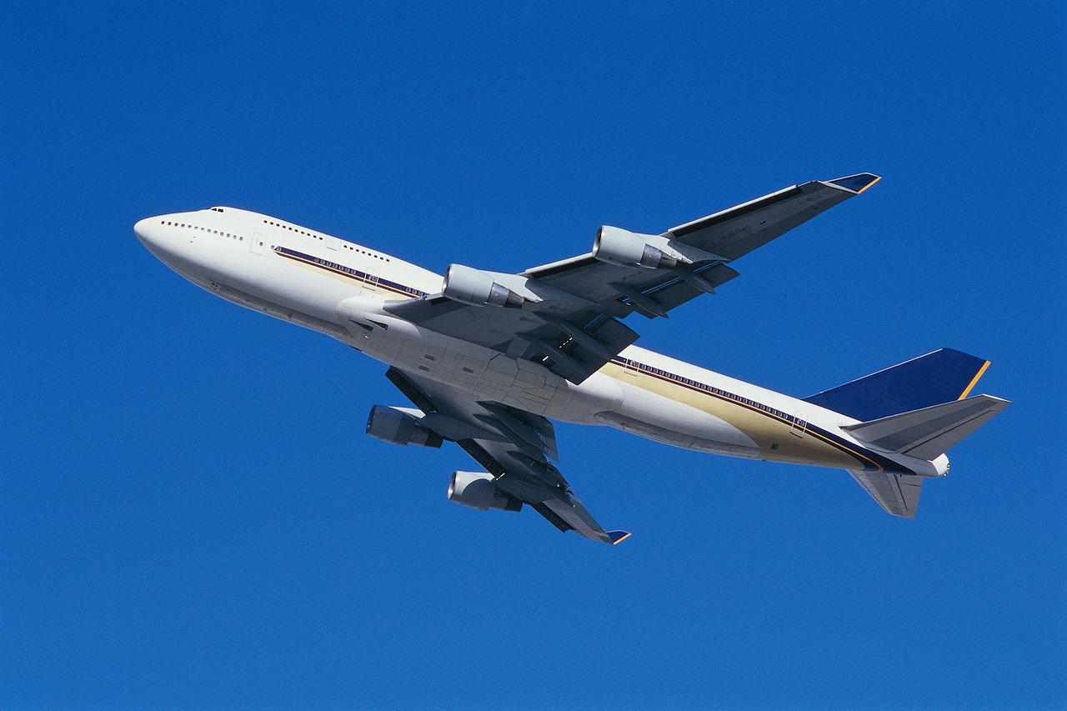

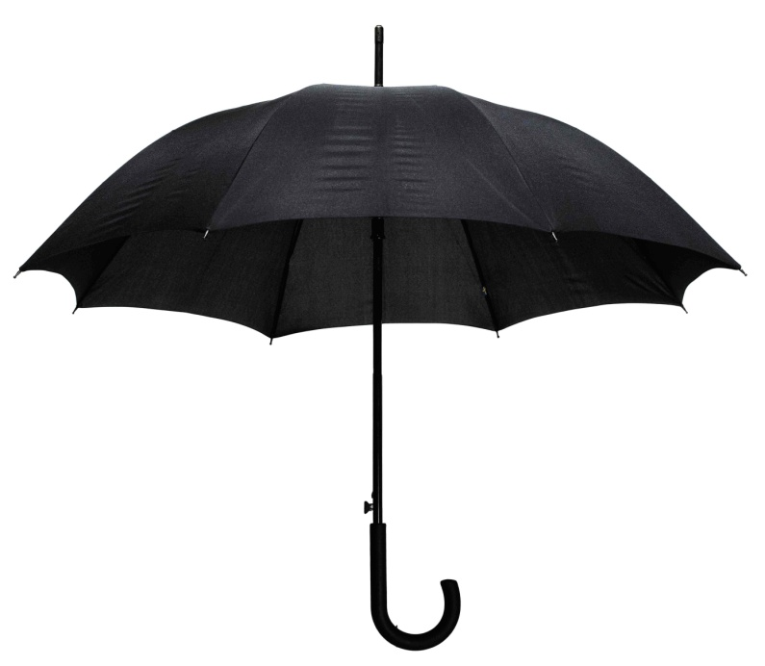
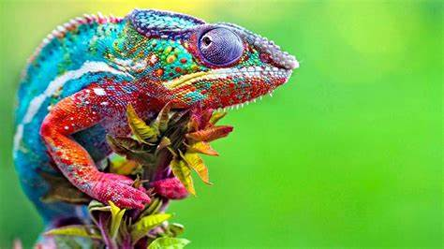

Games and Sports – Worksheet

Match the Tune
There are twelve pictures and each picture matches the name of a tune. You have to work out which picture goes with which tune. These are the list of tunes that you are looking to match. The list is not in the same order as the pictures:

- Karma Chameleon - by Boy George
- Riding in my car – by Madness
- Leaving on a jet plane – by John Denver
- I want candy – by Bow Wow Wow
- Rabbit – by Chas and Dave
- Who let the dogs out? – by the Baha Men
- Butterfly fly away – by Miley Cyrus
- These boots are made for walking – by Nancy Sinatra
- Firestarter – by Prodigy
- Ring my bell – by Anita Ward
- Umbrella – by Rhianna
- YMCA – by The Village People
You could print the pictures and then use counters, buttons or even pieces of dried pasta to place on the pictures when you think you know the answer. You could also play the game with friends and family with one of you reading out the names and the others trying to guess the right picture. Or you could work as a team and find the answers together.
Have fun!

