Worksheet – Games & Sports
Memory Game
This game is going to help you use your memory and observation skills in a fun way. You will need to collect 8 different objects from around your home that will fit, all at the same time, on top of your table or a tray. So nothing big or heavy!
Ideas of things you could use are:
Cup or mug
Pen or pencil
Coaster
Ruler
Teaspoon (or any type of spoon)
Mobile phone
Button
Drinking straw
10p piece
Rubber band
Bottle top
Door key
Paperclip
These are just some ideas but, if you aren’t able to get any things together, you can print off the picture sheet of different objects then cut them out to use instead.
When you have all your objects ready, you lay them out and have a good, long look at them. As if you are taking a picture of them in your head. You don’t have to use all 8 at once. You can start with only 2 if you like and then add others as you go along until you have built up to 8.
When you have looked at the objects and think you can remember them, get somebody to take one away whilst you close your eyes or look away. You can do this on your own by closing your eyes and taking one of the objects away but, it is easier if you have help. Now you have to look back at all the objects that are left and say which one is now missing.
That is how the game works. You can now keep taking one object away at a time until you are left with none in front of you. Or, you can put the object back in its place once you have guessed and then take a different object away.
The idea is to keep putting the objects back in the same place they came from. This will help you to remember them. If you find this too easy, you could have somebody move the objects around after one is taken away. Trying to guess which one was taken will be more tricky but, will be a good test of your memory and observation skills! You Superstar! Have fun.

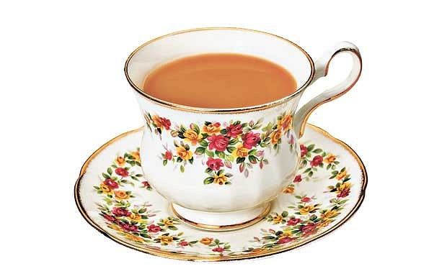 | 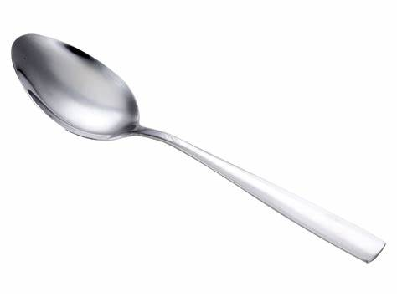
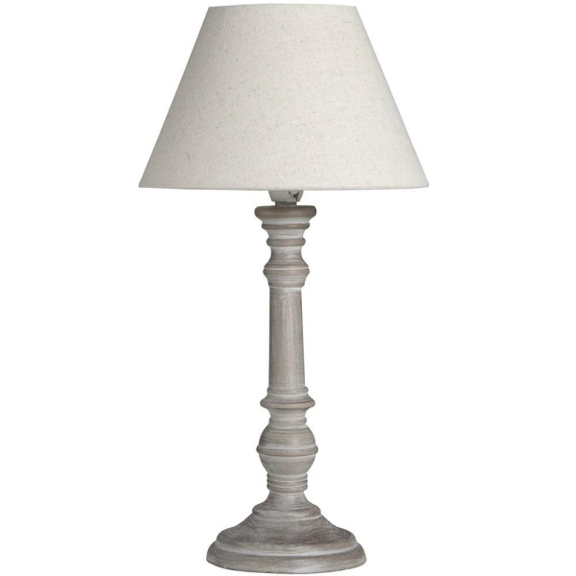 | 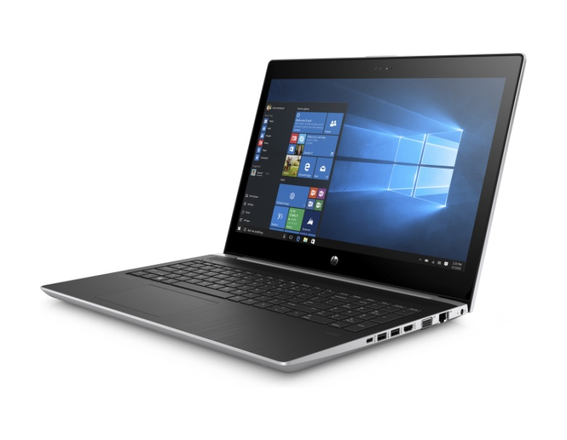
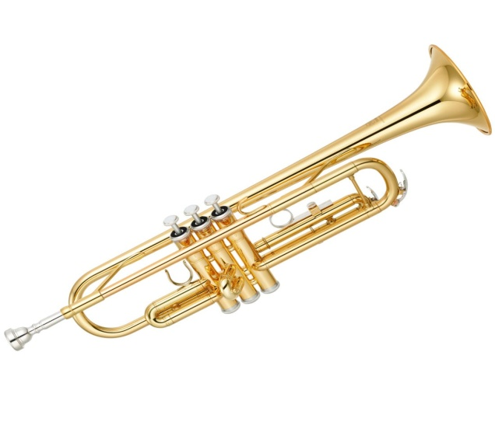 | 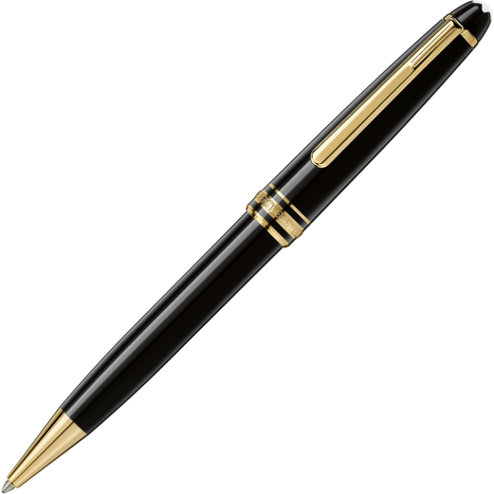
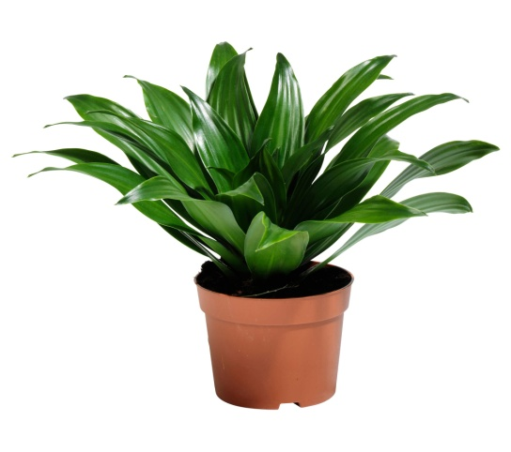 | 