GARDENING Name________________

Can you cut out the pictures on the next page and place them under good or bad for the garden

GOOD BAD

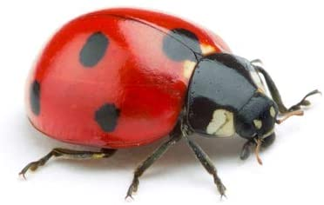 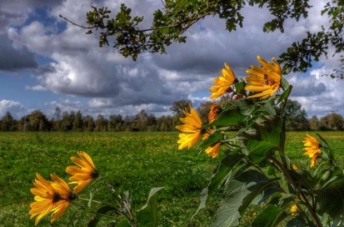

LADYBIRD STRONG WINDS

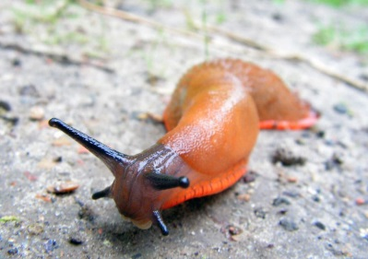 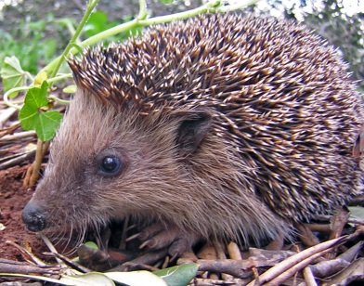

SLUGS HEDGEHOG

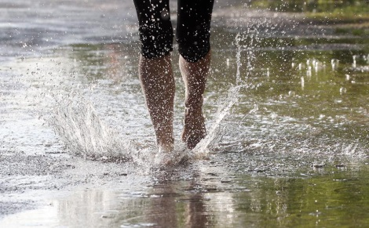 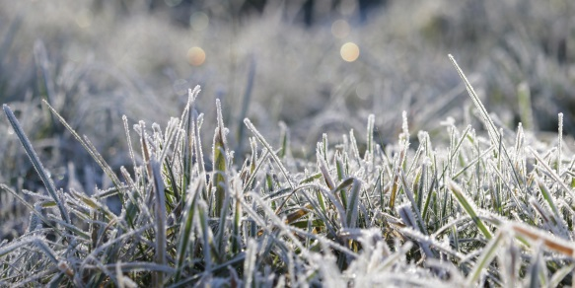

RAIN FROST

 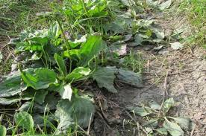

SUN WEEDS